============================== PROJECT REPORT=====================================

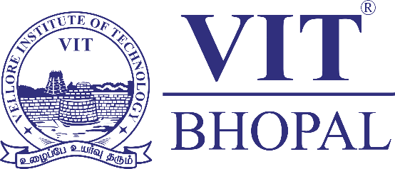

Title Page
Name: Jidnyesh Pujari
Reg No.: [25BAI10091]
Branch: B. Tech (CSE AIML)
Year: First Year
Course Code: CSE0001
Course Title: Digital Literacy
Date: [31 MARCH]

================================================================================

==============================================================================
Introduction
In today’s fast-paced digital world, being digitally literate is no longer optional—it is a necessity. This project was assigned as part of the Digital Literacy course, where I took on the role of a Student Digital Ambassador. The aim was to not only understand digital tools but also learn how to use them responsibly and effectively.
Throughout this project, I explored multiple aspects of digital literacy, including creating online content, building a professional presence, practicing coding, and understanding cyber safety. Each task gave me practical exposure and helped me connect theoretical concepts with real-world applications. This project has played an important role in shaping my awareness of how to behave responsibly and confidently in the digital environment.

================================================================================
Task 1 – Digital Literacy Infographic
For this task, I created a digital literacy awareness infographic using Canva. I chose topics such as safe internet practices, useful digital tools for students, and maintaining a professional online presence. My goal was to make the content simple, visually appealing, and easy to understand for my peers.
While designing, I focused on clarity and minimalism by using icons, colors, and short text. One challenge I faced was fitting meaningful content into a single page without making it look overcrowded. However, this process helped me improve my creativity and ability to present information effectively. It also made me realize how powerful visual communication can be in spreading awareness.

Task 2 – Digital Portfolio
In this task, I created and improved my profiles on platforms like GitHub and LinkedIn. These platforms are essential for building a professional identity in today’s competitive world.
GitHub allows me to showcase my coding projects and technical skills, while LinkedIn helps in building a professional network and sharing achievements. Creating a GitHub README was especially interesting, as it acts like a personal introduction page.
Going forward, I plan to regularly update these platforms with my projects, certifications, and skills. Over the next four years, I aim to build a strong digital portfolio that reflects my growth and helps me secure internships and career opportunities.

Task 3 – Coding & Collaboration Platforms
For this task, I explored platforms like HackerRank and Google Forms. On HackerRank, I completed a beginner-level coding problem, which helped me understand basic programming logic and problem-solving.
Additionally, I created a Google Form as a Digital Literacy Quiz. It included multiple-choice and short-answer questions, making it interactive and useful for collecting responses. This activity showed me how digital tools can be used for collaboration, feedback, and data collection.
These platforms will play a significant role in my academic journey by helping me improve my coding skills and collaborate effectively with others.

Task 4 – Email Etiquette & Communication
This task focused on professional communication. I wrote two formal emails—one requesting an assignment extension and another applying for a summer internship. This helped me understand the importance of proper structure, tone, and clarity in emails.
I also created a Social Media Do’s and Don’ts checklist, which emphasizes responsible online behavior.
A common issue in digital communication is sending poorly written or unclear messages. For example, emails without a subject line or proper greeting can create a negative impression. This task taught me that simple practices like being polite, clear, and structured can make communication much more effective.

Task 5 – Cybercrime Awareness
In this task, I explored UPI fraud, which is one of the most common cybercrimes in India today. I learned that most cybercrimes do not involve complex hacking but rely on manipulating people through trust and urgency.
What surprised me the most was how easily people can be tricked into approving payment requests or sharing sensitive information. It made me realize that awareness is the first line of defense against such crimes.
As a result, one habit I will change is being more cautious while making online transactions. I will always verify payment requests, avoid unknown links, and never share sensitive information like OTPs or UPI PINs.

Conclusion
This project has been a valuable learning experience that enhanced both my technical knowledge and digital awareness. I not only learned how to use various platforms but also understood the importance of responsible digital behavior.
Overall, this project has increased my confidence in navigating the digital world and prepared me to use technology in a safe, productive, and professional manner.

References
- https://canva.com
- https://github.com
- https://linkedin.com
- https://hackerrank.com
- https://forms.google.com
- https://cybercrime.gov.in

